CHEMICAL ENGINEERING TRANSACTIONS  VOL. , 2023 | A publication of
The Italian Association
of Chemical Engineering
Online at www.cetjournal.it

Guest Editor: Sauro Pierucci
Copyright © 2023, AIDIC Servizi S.r.l.
ISBN 978-88-95608-98-3; ISSN 2283-9216

Software-assisted determination of process dynamic model and PID tuning parameters for process control
Antonija Čelan^{a*}, Michele Miccio^{b}, Marija Ćosićª, Nenad Kuzmanićª
ª University of Split – Department of Chemical Engineering, Ruđera Boškovića 35, 21000 Split, Croatia
^{b} University of Salerno – Department of Industrial Engineering, Via Giovanni Paolo II 132, 84084 Fisciano (SA), Italy
antonija.celan@ktf-split.hr

The feedback control of temperature in a simulated batch reactor was studied in a class of the master’s degree in Chemical Engineering for educational purposes. The process was simulated in real-time by means of the software Simcet developed by PiControl Solutions LLC where a step test was performed in open-loop. The dynamic response of the process output (temperature) was observed and transfer function parameters were visually estimated and discussed. In the second part of the work, the dynamic response was fitted by a First Order Plus Dead Time model in the software PITOPS, by using the System Identification module. Determined transfer function parameters were compared to the ones visually estimated. Finally, the second module available in PITOPS, PID/APC Optimization allowed for determination of PID tuning parameters for several different tuning criteria (e.g. IAE, RO). The dynamic response of the process upon a set-point change was simulated in closed-loop, i.e., with controller in automatic mode. Finally, outputs for all tuning criteria applied were compared and discussed in detail.

The use of mentioned software as a teaching tool in Process Control course was found to be quite beneficial. Students were given an opportunity to gain basic but very practical skills which are essential for future process engineers. Also, the fact that these programs were used for optimization of processes in several large industrial plants in Croatia (Rijeka Refinery, Pliva, Cemex, Hospira/Pfizer, Xellia, etc.), made students involved in the exercises, but also more interested in the Process Control course itself.

KEYWORDS: process control, dynamical model, PID tuning, feedback control, learning by doing.

  - Introduction
An analysis of process dynamics can be considered as a prerequisite for successful process control. Most processes in chemical and other related industries are in unsteady-state, and thus, are described by dynamical models. These models represent a connection of process input (cause) and process output, which can be considered as an effect. For the purpose of process control, most processes in chemical and other related industries can be described by simplified dynamic models rather than developing complicated mathematical models, described by partial differential equations which can be difficult to solve (Čelan, 2020; Healy, 2011). Besides theoretical ones, gaining practical experiences in process control is indispensable for a future process engineer (Miccio et. al., 2019). Practical skills are gained in the control room and young process engineers, naturally, lack experience. This is why it is essential to incorporate tuning simulators into courses at the university level. The software used here was purchased for education purposes in Process Control at the Faculty of Chemistry and Technology, University of Split. Simcet is a real-time, online PID tuning simulator for practice and testing of tuning skills that mimics the control room environment. Its major advantage is that it operates in the time-domain. It is user friendly, easy to understand and very helpful in visualizing processes and control methods which are sometimes rather abstract to students. It offers a range of processes for students to analyse. The second one, Pitops, is a multivariable closed-loop process transfer function dynamics system identification tool. Both were used in this work to test the benefits for exercises in Process Control course. During the semester, students put their hands in a PC-equipped lab class on the case study presented here and the software proved to be a great addition to the theoretical lectures. The ease of-use and the fact that the programs operate entirely in the time domain helped students grasp the complexities of process control. The fact that they could simulate processes, safely change PID parameters and observe the effects, made them more involved in the course.
  - Materials and methods
Simulations were conducted in real-time by means of the software Simcet by PiControl Solutions. It this case, temperature control on batch reactor was analysed. The simulator allows to test both closed and open loop dynamics by changing the controller mode from auto to manual. Changes in PV, SP and OP can be observed in diagrams shown below the PFD in the simulator. The second software used here was Pitops, which is a process identification & controller tuning optimizer simulator. It consists of System Identification module and PID/APC Optimization module. The first one is used for identifying process dynamics (transfer function parameters) while the second one is used for controller tuning. The adopted methodology consisted in a detailed description of the process being analysed in Simcet, upon which it was necessary to conduct a step test in an open-loop configuration. Obtained dynamic response was then inspected and transfer function parameters were visually estimated. Additionally, Pitops System Identification module was used to analyse the dynamic response which was fitted by a First Order Plus Dead Time model in Pitops. Transfer function (TF) parameters were optimized. In the Pitops PID/APC Optimization module, different tuning criteria were applied for determination of PID tuning parameters. While there are several different tuning criteria available in Pitops, including common ones like Ziegler-Nichols and Cohen Coon, only the criteria which were developed by PiControl Solutions specifically for Pitops were used here. The tuning criteria applied were Pitops-IAE that minimizes the integrated absolute error and Pitops-RO that produces stable and crisp control but with reduced proportional kick in order to minimize an overshoot upon a set-point change. Obtained responses to a set-point change were analysed and discussed.
  - Results and discussion
Simplified piping & instrumentation diagram (P&ID) is shown in Figure 1.
Figure 1: Simplified piping & instrumentation diagram of temperature control on batch reactor.
As can be seen in the P&ID, the temperature controller (TC) receives info on the process variable (PV) being measured by a sensor, which in this case is the temperature in the semibatch reactor. The sensor has a range of 0 – 500 °C. In automatic mode, the TC compares PV, i.e., the reactor temperature, to the set-point (SP) given by the operator. Based on the error and selected PID algorithm, it calculates the controller output (OP) that is being sent to the final control element in the loop, i.e. the valve in order to reject the effect of disturbances. The valve opens/closes based on the controller output and adjusts the condensing steam flow rate in the reactor jacket, which is the manipulated variable.

    - Simulation of a step test in the open-loop configuration

In order to analyse the open-loop response, the controller mode was set to manual. Two graphs are visible below the P&ID. The upper one showing the PV (red line) vs. time (in minutes).

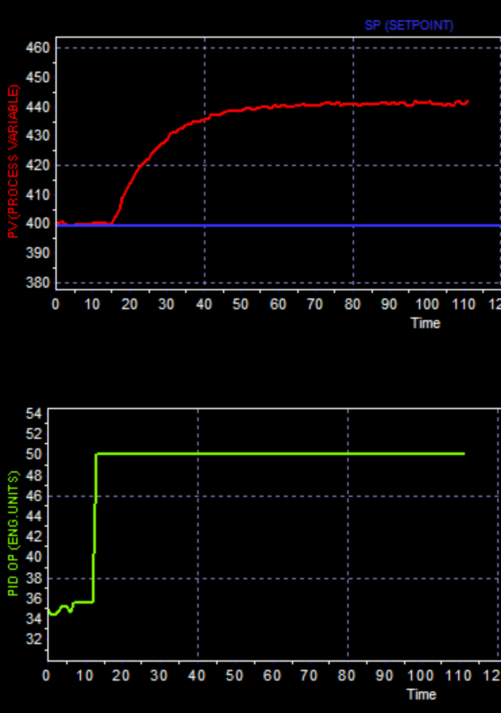
Figure 2: Dynamic response to a step change in controller output from 35 % to 50 % (a screenshot from Simcet).
The lower graph shows the controller output OP in % (green line) which is mastering the steam flow rate vs time (in minutes). In order to analyse the dynamic response of the process in the open-loop, a step test was conducted by changing the OP from 35 % to 50 %. As can be seen from Figure 2. for the first couple of minutes after the step change in OP there is no change in PV. If ideal mixing is assumed in the reactor, the dead time can be considered a consequence of the resistances to heat transfer in the system. After the elapse of the dead time, reactor temperature rises from 400 °C to approximately 440 °C where it settles, signalling that the dynamic system investigated here is self-regulating. By visually inspecting the response, besides estimating the dead time to approximately 3 minutes, it can be seen that the system reaches the new steady state (time to steady state, TTSS) within approximately 55 minutes.

    - Software assisted determination of process dynamic model
In order to determine the transfer function parameters, collected process output data was imported to Pitops and analysed in System Identification module.
Based on the fact that the system is self-regulating and that the rate of change of PV is maximum after the elapse of the dead time, the process was fitted with a first order plus dead time (FOPDT) model. In Figure 3.a., raw data collected from Simcet is represented by red line while the blue line represents the fitted FOPDT model:
$$τ\frac{dT}{dt}+T=K_{p}∙OP∙\left(t-θ\right)$$ | (1)
Process time constant, τ, the process gain, K_{p}, the dead time, θ, along with the model validation criteria (FIT, NRMSE, IAE) determined by Pitops are shown in Table 1.

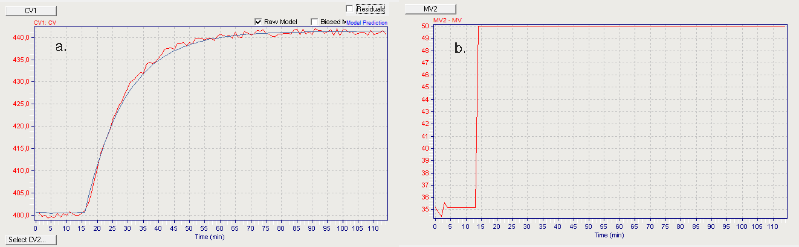
Figure 3: Dynamic response (a.) to a step change in controller output from 35 % to 50 % (b.), a screenshot from Pitops.
Table 1: Determined process model parameters and model validation criteria.
τ, min | K_{p}, °C/% | θ, min | FIT, % | NRMSE, - | IAE, °C
13,62794 | 2,74994 | 2,7547 | 99,79 | 0,046 | 0,654

Here, the FIT criterion of a model describes the goodness of fit to PV values. It ranges from 0% to 100%, whereas 100% indicates the perfect model. The NRMSE (Normalized Root-Mean-Square Error) criterion is the normalized standard deviation of the residuals (prediction errors), i.e. it gives information about how concentrated the data is around the line of best fit. NRMSE ranges from 0 to 1, where NRMSE = 0 indicates that the model is perfect. The IAE (Integral Absolute Error) criterion is the sum of all areas where values predicted by the model are above or below the PV value, divided by the number of samples. IAE ranges from 0 to infinity, where IAE = 0 implies that the model is perfect. Obtained validation criteria indicate high goodness of fit.

    - Software assisted determination of PID tuning parameters

Based on determined process parameters, the PID tuning parameters were determined in PID/APC Optimization module. In PID Configuration window, instrument ranges (CV range, MV range) along with PID scan time and tuning time unit were matched with process settings in Simcet. While Pitops offers additional PID setting, such as initial PID output, PV sample delay, valve characterizer and transformation of PV signal, they were not edited here and process linearity was assumed.

As a PID algorithm, equation marked as B0 in PID Configuration window was used since it is one of the most popular ones. In the discrete time domain, it is:
$${OP}_{n}={OP}_{n-1}+P\left[∆E+\frac{E∙∆t}{I}+D\frac{∆\left(∆PV\right)}{∆t}\right]$$ | (2)
where calculated OP_{n} is the current control valve position, OP_{n-1}, the previous PID calculation, E is error calculated as (PV-SP) and Δt is the PID scan time. Parameters P, I and D represent the proportional gain, the integral time and the derivative time, respectively. It is worth noting that in equation (2), the derivative acts on the deviation of PV rather than on the error.
To calculate the optimal PID parameters there several available tuning criteria in the software. These include tuning methods such as Ziegler-Nichols, Cohen-Coon, Internal model control and Lambda PI and PID criteria. While there is a range of possible methods that could be used in Pitops, in this work only the methods developed especially for Pitops were applied and compared.
Considering that the controlled variable is the reactor temperature, PID controller action was considered. To determine “the upper limit” of the PID parameters, that are on the aggressive side, the Pitops-IAE method (see Eq.2.) was used. The method minimizes the absolute error (PV-SP) over the simulation period (Seborg et al. 2016). PID tuning parameters obtained by the said method are listed in Table 2.
$$IAE=\int_{0}^{∞}{\left|e(t)\right|dt}$$ | (2)
Table 2: PID parameters obtained with Pitops-IAE method.
Controller gain | Integral time,  min | Derivative time,  min | Error
4,25166 | 16,54945 | 1,53017 | 46,042

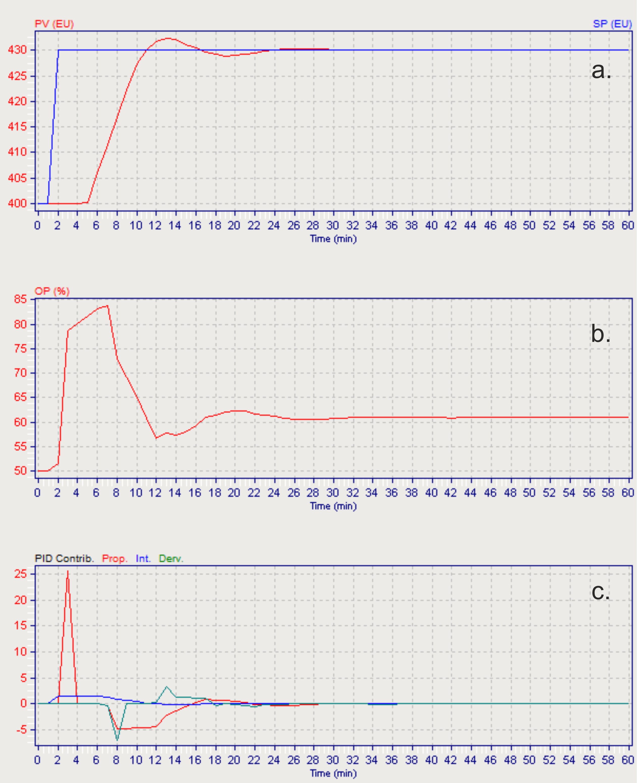
Figure 4: Results obtained with Pitops-IAE method: response to a set-point change (a.) OP vs time (b.) proportional, integral and derivative contributions.
Process response to a set-point change in a closed loop configuration is shown in Figure 4, along with the OP vs time as well as the proportional, integral and derivative contributions.
As can be seen, at the beginning the PV is at steady state at 400 °C. Upon a set-point change to 430 °C, there is an apparent dead time (≈ 4 minutes) during which the PV remains at 400 °C, after which it rises and ≈ 10 minutes after the change in OP, reaches the new steady-state value for the first time. Also, it can be seen that the PV overshoots the set-point. This sharp rise of the PV is a consequence of the proportional kick, visible in Figure 4b., where the OP (i.e. the valve position) rises from 50 % to almost 80 %, after which the integral contribution (see Figure 4c.) kicks in and decreases the rate of change of the OP. Finally, the derivative contribution acts to decrease the OP which eventually settles at approximately 60 %. As can be seen from the figure, in closed-loop configuration with PID parameters determined with Pitops-IAE method, the process reaches the new steady state (TTSS) in approximately 23 minutes.

The second method applied was Pitops-RO (reduce overshoot). PID parameter determined by this method are given in Table 3.
Table 3: PID parameters obtained with Pitops-RO method.
Controller gain | Integral time,  min | Derivative time,  min | Error
1,56346 | 11,29112 | 0,28352 | 80,614

Since the main idea of the method is to prevent the PV from overshooting the set-point, the controller gain is twice as low than the one determined with the Pitops-IAE method. Also, both integral time and derivative time are lower while the error is increased. Process response to a set-point change from 400 °C to 430 °C in closed-loop configuration with PID parameters listed in Table 3. is shown in Figure 5a.

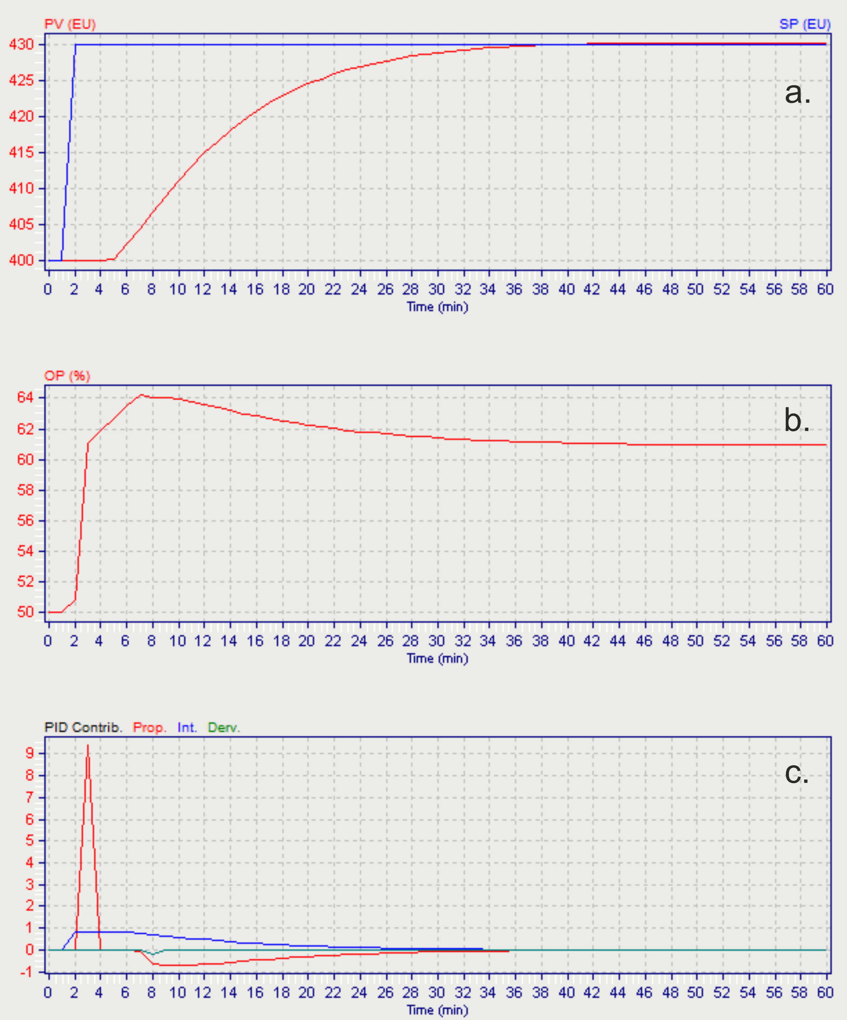
Figure 5: Results obtained with Pitops-RO method: response to a set-point change (a.) OP vs time (b.) proportional, integral and derivative contributions.
As is the previous case, here, the set-point is changed from 400 °C to 430 °C. There is an apparent dead-time of 4 minutes after which the PV rises and reaches the set-point value within 37 minutes. At the same time, at the beginning, the valve position increases sharply from 50 % to 61 % (Figure 5b.) as a consequence of the proportional contribution (Figure 5c.). Integral contribution reduces the rate of change of the OP, which rises additionally to 64 %, while the derivative contribution finally acts to drop the OP to the final value of approximately 61 %. Vector files were generated in the software in order to compare normalized process responses to a set-point change obtained by the two methods. These are shown in Figure 6. As can be seen, with PID parameters determined by Pitops-IAE, the process response settles within ± 1 % in ≈ 22 minutes from the set-point change. On the other hand, settling time with parameters determined by Pitops-RO is somewhat longer and equals approximately 35 minutes. Also, as can be seen in the figure, there is a minimal overshoot (less than 1 %) in case when PID parameters calculated with Pitops-RO method are applied.

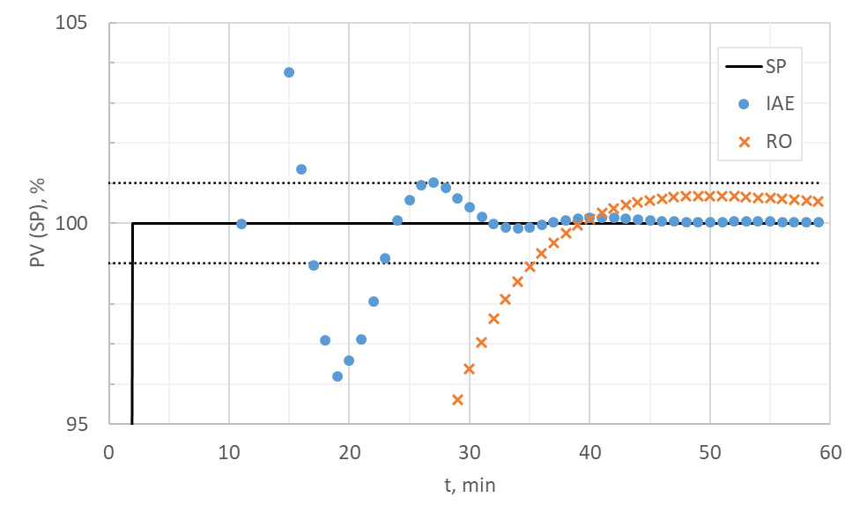
Figure 6: Comparison of normalized process responses (partially shown from 95 – 105 %).

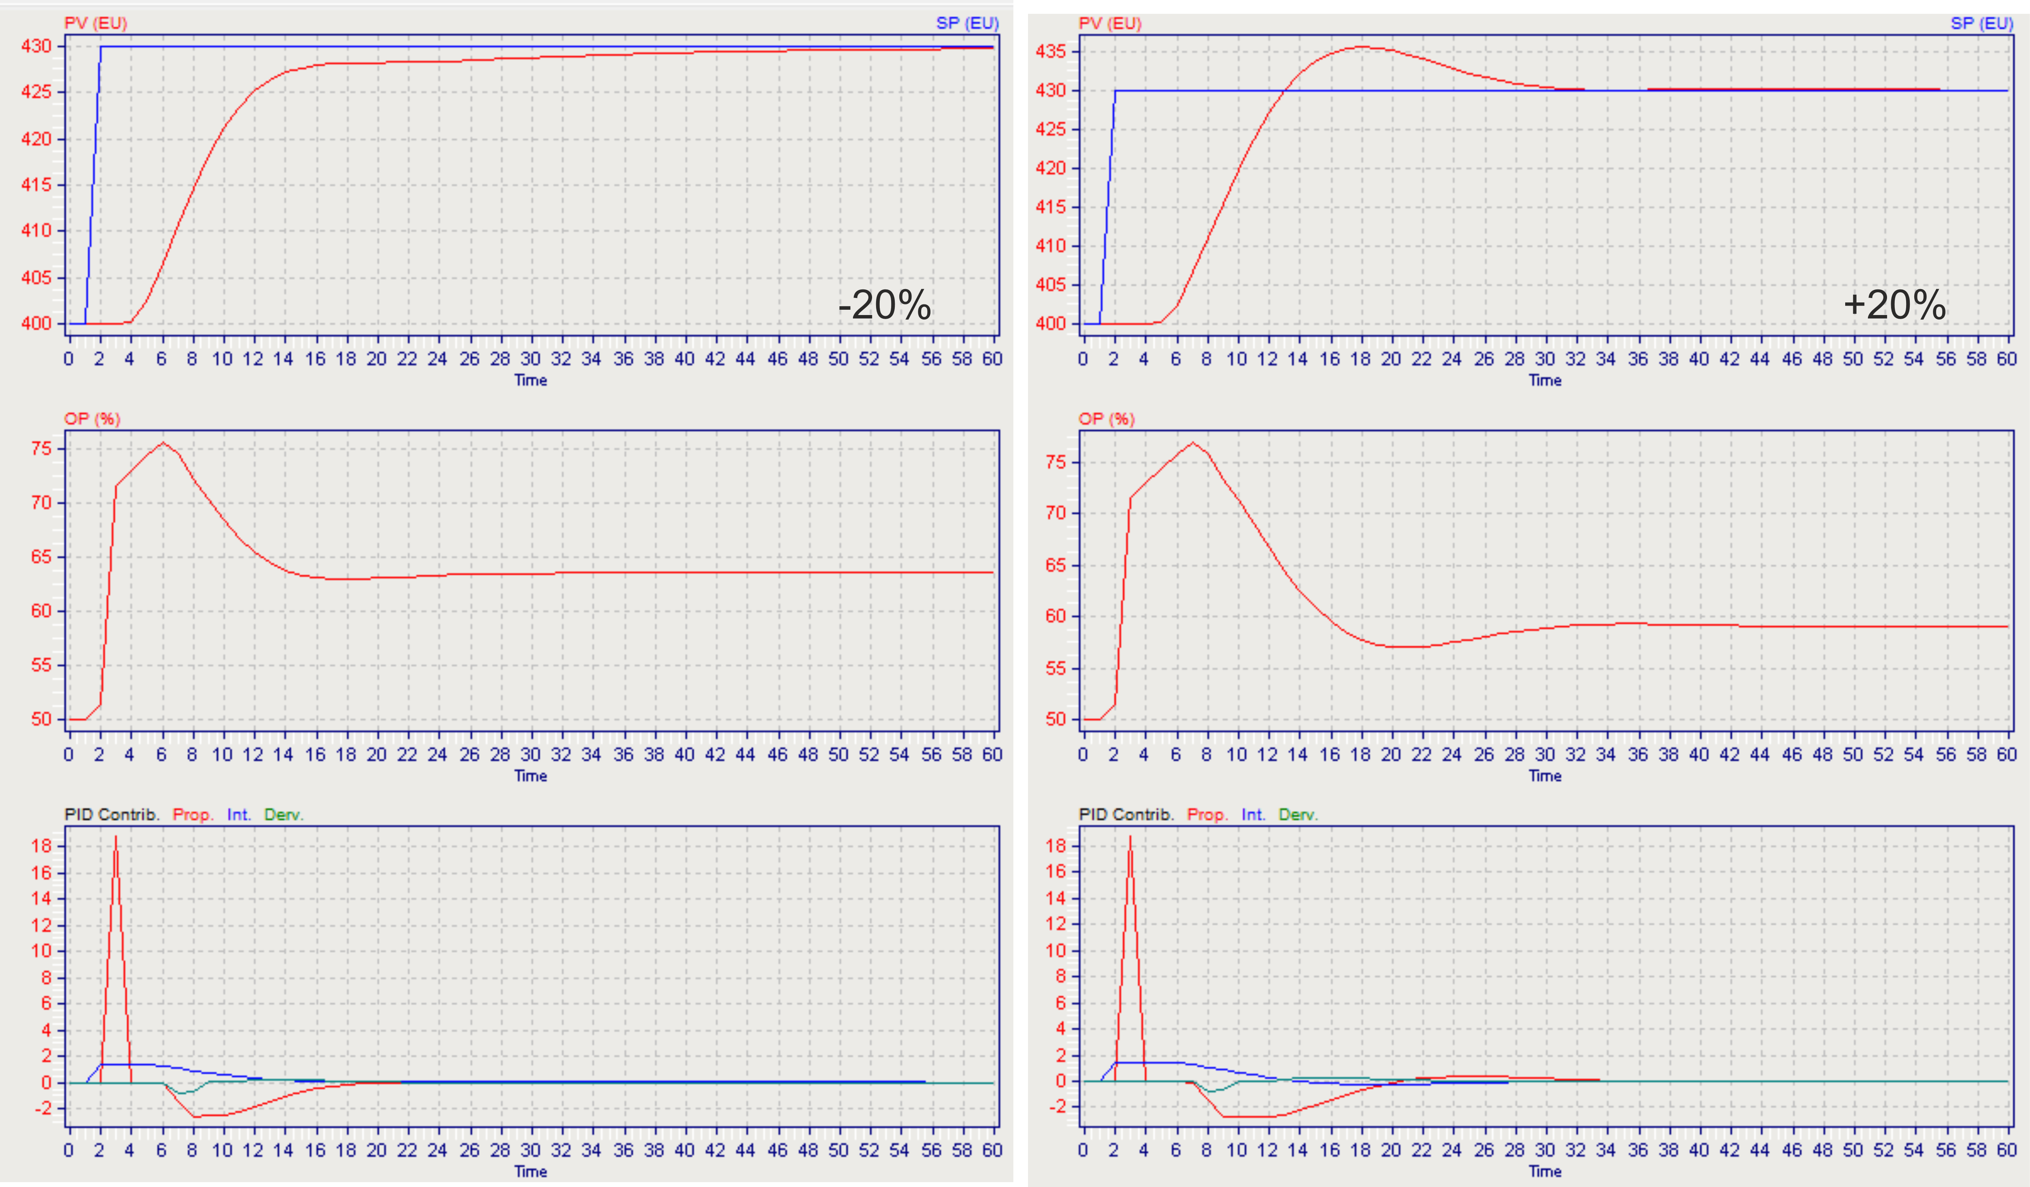
Figure 7: Robustness analysis of PID tuning parameters determined by Pitops-IAE method (response to change of transfer function parameters by ± 20 %).

Finally, a robustness analysis was conducted in Pitops in order to test the robustness of the determined PID parameters, that is, to test the PID response to a change in transfer function parameters. Here, transfer function parameters determined previously (see Table 1.) were decreased and increased by 20 % and PID response was observed. The results of an analysis conducted for PID parameters determined by Pitops-IAE method is shown in Figure 7.

As can be seen from the figure, a decrease of TF parameters by 20 % results in a sluggish process response and an increase of the time to new steady-state to ≈ 55 minutes. On the other hand, an increase of TF parameters by 20 % resulted with an overshoot of almost 5 °C and an increase of TTSS to ≈ 33 minutes.

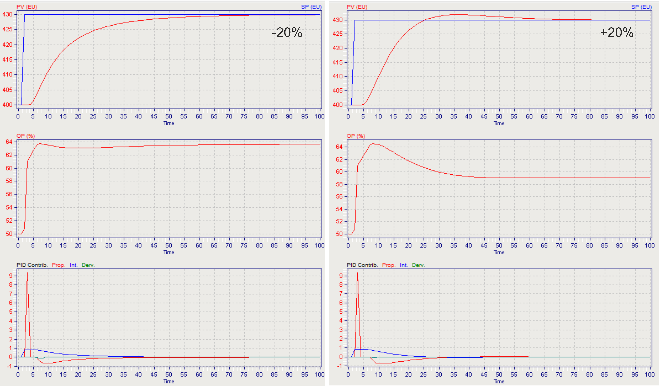
Figure 8: Robustness analysis of PID tuning parameters determined by Pitops-RO method (response to a change of transfer function parameters of ± 20 %).
Similar was observed in the case with PID parameters determined by the RO method (Figure 8.). When all TF parameters are decreased by 20 %, the response gets more sluggish (TTSS ≈ 80 minutes), and when TF are increases, the response exhibits an overshoot and TTSS ≈ 72 minutes. The robustness analysis gives a clear indication if the same PID parameters can be applied when TF parameters change. Generally, the control objective would be to accomplish a stable response to a set-point change. But, if an exothermic reaction is taking place in a reactor, the objective should be to attain a stable response without overshoot, considering the fact that the rate of reaction exponentially increases with temperature (Liptak, 2006). Tuning the controller to prevent overshoot could also be beneficial for processes in which the reaction mixture is sensitive to temperature change, such as in bioreactors, in reactors with polymers, etc. In those cases, overshooting the set-point may result in product deterioration, generation of a byproduct etc. and PID parameters should be determined in such a way to achieve the control goal. The use of this software greatly simplifies the procedure.

  - Conclusions
Presented methodology for software assisted determination of transfer function parameters as well as the PID tuning parameters greatly simplifies the procedure. The programs are user friendly, easy to understand and very helpful in visualizing processes and control methods which are sometimes rather abstract to students. The fact that the process can be simulated in Simcet and then analysed in Pitops gives an opportunity to safely practice and upgrade their tuning skills.
References
Čelan A., 2020, Dinamički modeli za analizu i vođenje procesa, Kemija u industriji, 69 (9-10) 589–589.
Healy M., 2011, Performance Analysis of Batch Reactor Temperature Control Systems, Masters Dissertation. Technological University Dublin, 12–13.
Liptak B.G. (Ed.), 2006, Instrument Engineers' Handbook, Process Control and Optimization, Vol. 2., 4th Edition-CRC Press.
Miccio M., Cascone G., Cosenza B., Forte M., Fragranza M., Brachi P., Celan A., 2019, Process Measuring, Monitoring and Control at Lab-scale: an Added Value for Practical Training, Chemical Engineering Transactions, 74, 1267–1272.
Seborg D.E., Edgar T.F., Mellichamp D.A., Doyle F.J., 2016, Process Dynamics and Control, 4th Edition, Wiley, USA, 206–210.

